Week 3 Data Modelling Report
Agricultural Crop Yield Prediction using Random Forest Regression

1. Objective
The objective of this Week 3 project is to create and evaluate a machine learning model using the cleaned agricultural crop-yield dataset. Since Yield is a continuous numerical variable, the project is formulated as a supervised regression problem. The workflow includes feature selection, categorical encoding, an 80:20 train-test split, Random Forest Regression, prediction, evaluation and documentation.

2. Dataset
The modelling dataset contains 1200 observations and 15 columns. The target variable is Yield. The dataset includes agricultural variables such as Area, Production, Annual_Rainfall, Fertilizer and Pesticide, together with categorical crop information.

3. Feature Selection and Target Leakage
Yield is selected as the target. Yield and Yield_Normalized are excluded from the predictors because Yield_Normalized is derived directly from the target and would leak target information into the model. Normalized versions of input variables are also excluded because their original variables already provide the same information.

4. Categorical Encoding
Categorical columns are converted into numerical features using One-Hot Encoding. The encoder uses handle_unknown='ignore', which allows unseen categories in the test set to be handled safely. Numerical variables are passed through without scaling.

5. Train-Test Split
The data is divided into 80% training and 20% testing data. The training set contains 960 observations and the test set contains 240 observations. random_state=42 is used to make the experiment reproducible.

6. Algorithm Selection
Random Forest Regressor was selected because crop yield can have non-linear relationships with rainfall, area, fertilizer, pesticide, crop type and production-related variables. Random Forest combines predictions from many decision trees and is well suited to structured tabular data. It also provides feature importance values for interpretation.

7. Model Configuration
The Random Forest uses 300 trees, random_state=42, n_jobs=-1 for parallel processing, and max_features='sqrt'. Preprocessing and modelling are combined in one scikit-learn Pipeline so the same transformations are applied consistently.

8. Main Code
X_train, X_test, y_train, y_test = train_test_split(
X, y, test_size=0.20, random_state=42
)
preprocessor = ColumnTransformer([
("categorical", OneHotEncoder(handle_unknown="ignore"), categorical_cols),
("numeric", "passthrough", numeric_cols)
])
model = RandomForestRegressor(
n_estimators=300, random_state=42, n_jobs=-1, max_features="sqrt"
)
pipeline = Pipeline([
("preprocessor", preprocessor),
("model", model)
])
pipeline.fit(X_train, y_train)
y_pred = pipeline.predict(X_test)

9. Model Evaluation
Metric | Value
MAE | 0.3763
MSE | 0.3863
RMSE | 0.6216
R² | 0.9127
MAE is the average absolute prediction error. MSE is the average squared error and penalizes larger errors more strongly. RMSE is the square root of MSE and is expressed in the same unit as Yield. R² measures the proportion of variation in Yield explained by the model on the unseen test set.

10. Actual vs Predicted Yield
Points closer to the diagonal reference line indicate closer agreement between actual and predicted yield values.
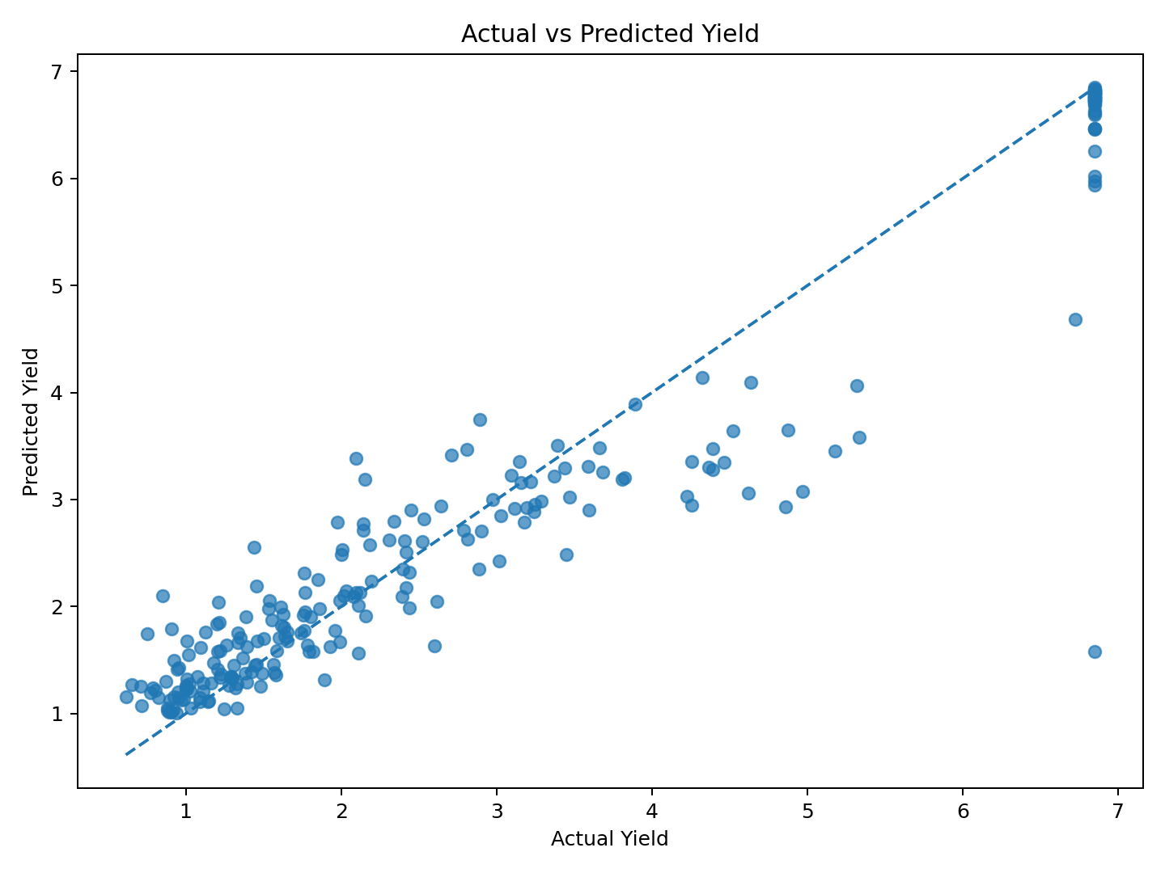

11. Residual Analysis
Residuals are Actual Yield minus Predicted Yield. A relatively random spread around zero is desirable because it suggests fewer obvious systematic errors.
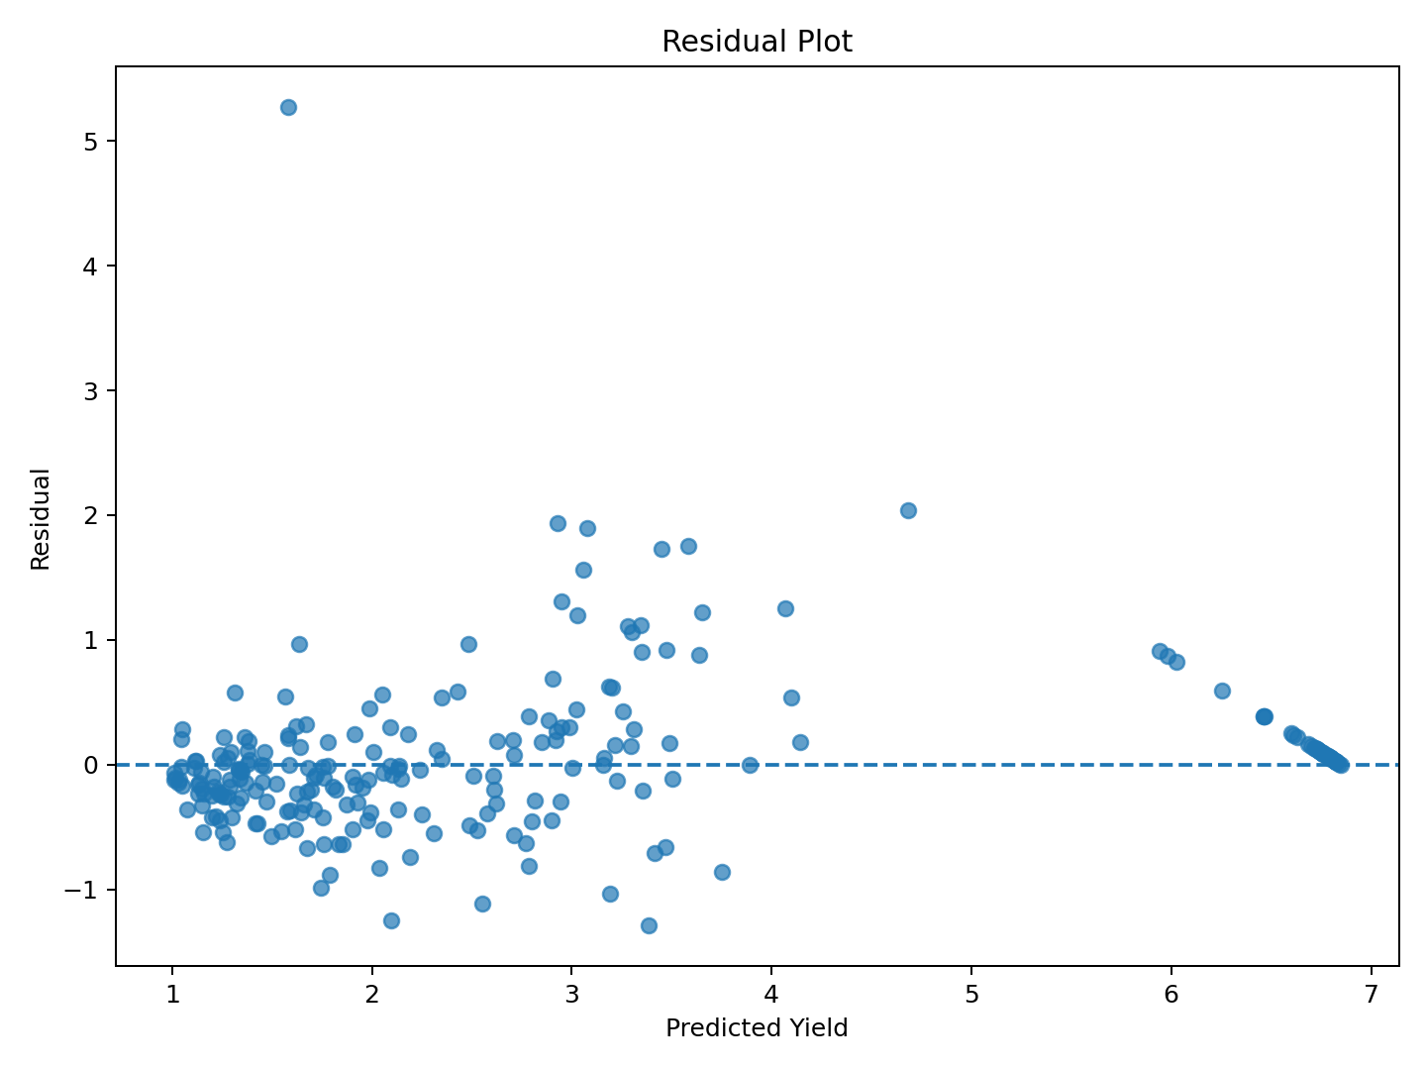

12. Feature Importance
Feature importance shows which transformed input variables contributed most to the Random Forest predictions. Importance indicates predictive contribution, not causation.
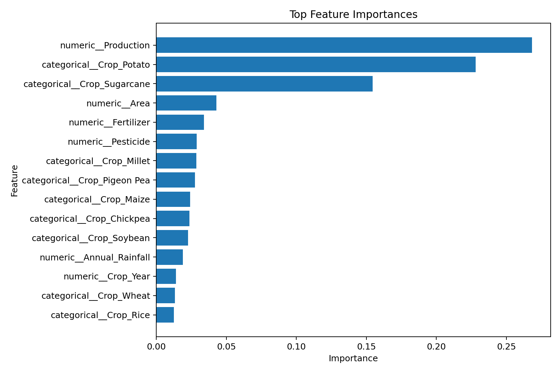

13. Key Results
The final Random Forest model achieved MAE=0.3763, MSE=0.3863, RMSE=0.6216, and R²=0.9127 on the test set. These metrics provide a baseline for predicting agricultural crop yield from the available features.

14. Assumptions
The model assumes that the cleaned historical data is reasonably representative of the prediction problem and that the selected features contain useful information about Yield. Random Forest does not require linear relationships, normally distributed predictors, or feature scaling. However, unmeasured factors such as soil quality, temperature, irrigation, disease and farm management may influence yield.

15. Limitations and Future Improvements
- Use k-fold cross-validation for a more stable performance estimate.
- Tune Random Forest hyperparameters using RandomizedSearchCV or GridSearchCV.
- Compare the model with Linear Regression, Gradient Boosting and XGBoost.
- Add soil, temperature, humidity, irrigation and regional features if available.
- Validate the final model on independent future-year data.

16. Conclusion
The Week 3 modelling workflow was completed using Random Forest Regression. The cleaned dataset was transformed safely, split into training and testing subsets, and evaluated on unseen data. The resulting MAE was 0.3763, RMSE was 0.6216, and R² was 0.9127. The model is a useful baseline for crop-yield prediction, while cross-validation, hyperparameter tuning and additional agricultural variables can be used to improve future performance.

